WALMART SALES PERFORMANCE DASHBOARD
Name | ASHWINI.A
Department | B.COM FINTECH & AI
Roll No. | E25FA004
Tool Used | Microsoft Power BI Desktop

Introduction
Walmart is one of the world’s largest retail companies, operating a wide network of stores and serving millions of customers. Managing sales across many locations requires careful analysis of historical data, customer demand, seasonal patterns, holidays, and economic conditions.
This project focuses on analyzing Walmart’s weekly sales data to understand how sales differ across stores and departments over time. The dataset can be used to identify high- and low-performing stores, observe changes in sales during holidays, and study the relationship between sales and external factors such as temperature, fuel price, consumer price index (CPI), and unemployment rate.
The main purpose of this analysis is to transform raw sales data into useful business insights. By using charts, comparisons, and forecasting techniques, Walmart can better predict future sales demand. These predictions can support decisions related to inventory management, employee scheduling, product availability, promotional campaigns, and store operations.

Objective of the Analysis
The main objective of this sales analysis is to evaluate the weekly sales performance of 45 stores. It helps answer important business questions, such as: How many stores are included in the analysis? What is the total sales amount? What is the average sales value? How many transactions were recorded? Which stores have high sales and which stores need improvement? The dashboard supports management in taking data-based decisions.

KPI CARDS:
Metric | Value | Meaning
Store Count | 45 | Number of stores in the dataset
Average Sales | 1.05M | Average sales value per recorded entry
Total Weekly Sale | 6.73bn | Combined weekly sales of all stores: 6,734,660,053.43
Transaction Count | 6K | Total transactions/records: 6,436

Overview of Store Count
The dashboard shows a store count of 45. This means the dataset contains sales data from 45 different stores. This measure is important because it indicates the scale of the business analysis. Since the report includes many stores, management can compare their sales results and identify differences in performance between locations.
Average Sales Performance
The average sales value shown in the dashboard is 1.05 million. Average sales are calculated by dividing the total sales value by the number of sales records or observations. This measure gives an idea of the normal sales level within the dataset. It can be used as a reference point: stores with average sales above 1.05 million may be performing better than the general level, while stores below this value may need additional analysis.
Total Weekly Sales
The total weekly sales value is 6.73 billion, with the exact total shown as approximately 6,734,660,053.43. This represents the combined weekly sales amount of all stores in the dataset. It is a major indicator because it shows the overall revenue earned by the business. A large total sales value indicates that the stores collectively generate substantial revenue.
Transaction Count Analysis
The dashboard displays a transaction count of 6K, meaning around six thousand records. The detailed total is 6,436 transactions. A transaction refers to an individual sales record included in the data. Transaction count is important because total sales alone does not show the full picture. A store may achieve high sales through many small transactions or through fewer high-value transactions. Therefore, analysing both sales value and transaction count gives a better understanding of customer purchasing behaviour.
Store-Wise Sales Comparison
The detailed table on the right side of the dashboard shows four fields: Store, Total Weekly Sale, Average Sales, and Transaction Count. The Store column identifies each store by number. Total Weekly Sale shows the overall sales generated by that store, while Average Sales shows its average sales amount. Transaction Count shows the number of records available for each store. This table helps compare performance across stores in a clear and organised way.
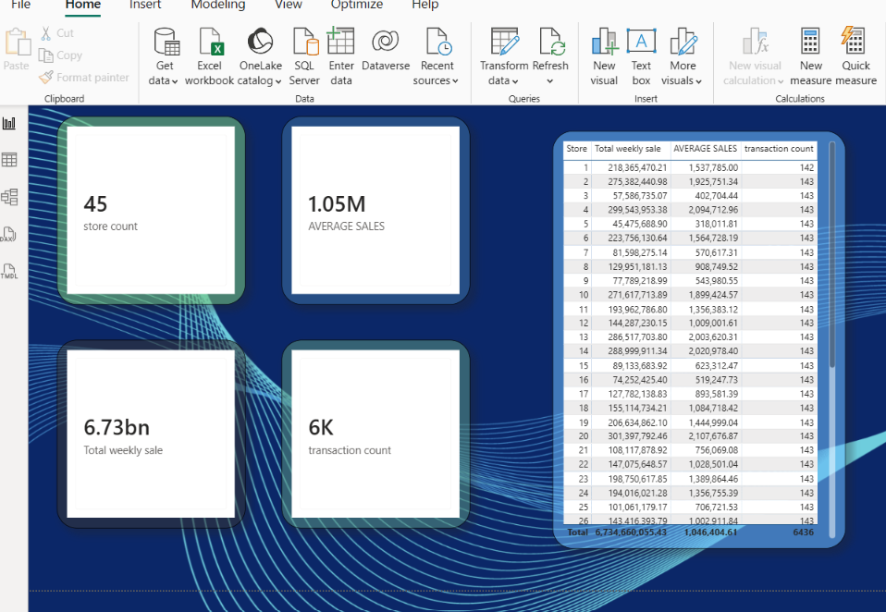

FINANCIAL VISUALAIZATION-1:

Store-Wise Total Weekly Sales
The chart titled “Store Wise Total Weekly Sales” compares the total weekly sales of all stores. Each vertical bar represents one store, and the height of the bar shows its total sales value. Stores with taller bars have generated higher sales, while stores with shorter bars have generated lower sales. This visual is useful for identifying the stores that contribute the most and least to overall revenue.
Average Weekly Sales by Store
The “Average Weekly Sale by Store” chart shows the average sales value for each store. It is displayed as a horizontal bar chart, where a longer bar represents a higher average weekly sale. This chart is important because total sales alone may not show regular sales performance. A store may have one very high sales period, but average sales help show its normal or typical sales level.
Weekly Sales Trend
The “Weekly Sales Trend” line chart shows how total weekly sales change over time. The line moves up and down because sales are not the same every week. Sharp upward peaks represent weeks with very high sales, which may happen because of festivals, holidays, special offers, seasonal demand, or promotional campaigns. Lower points represent weeks with reduced sales. This visual helps management understand sales patterns and prepare for high-demand periods.
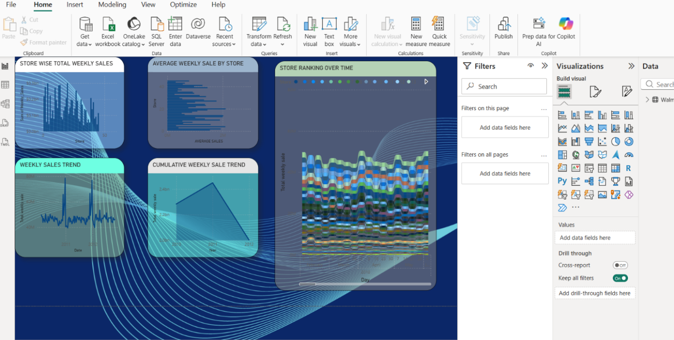

FINANCIAL VISUALAIZATION-2:

Holiday vs Non-Holiday Sales
The donut chart compares total sales during holiday weeks and non-holiday weeks. The chart shows that non-holiday sales contribute approximately 6.23 billion, which is 92.5% of total sales. Holiday sales contribute approximately 0.51 billion, which is 7.5% of total sales.
This does not necessarily mean that holiday weeks have poor sales. Non-holiday weeks are normally much more frequent than holiday weeks in a year, so they naturally contribute a larger total sales amount. To make a fair comparison, the business should also compare the average sales per holiday week with the average sales per non-holiday week.

Weekly Sales vs Fuel Price

The scatter chart shows the relationship between weekly sales and fuel price. Each dot represents a sales record or store-week observation. The horizontal axis shows fuel price, while the vertical axis shows total weekly sales.
The dots are spread across different fuel-price values, mainly between 2.5 and 4.0. Sales values also vary widely at similar fuel prices. This suggests that fuel price does not have a strong direct relationship with weekly sales. Some high sales values occur at both low and high fuel prices, while lower sales values are also present across the range.

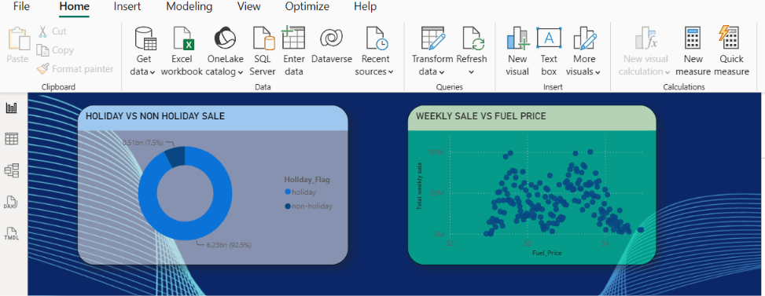

FINANCIAL DASHBOARD:

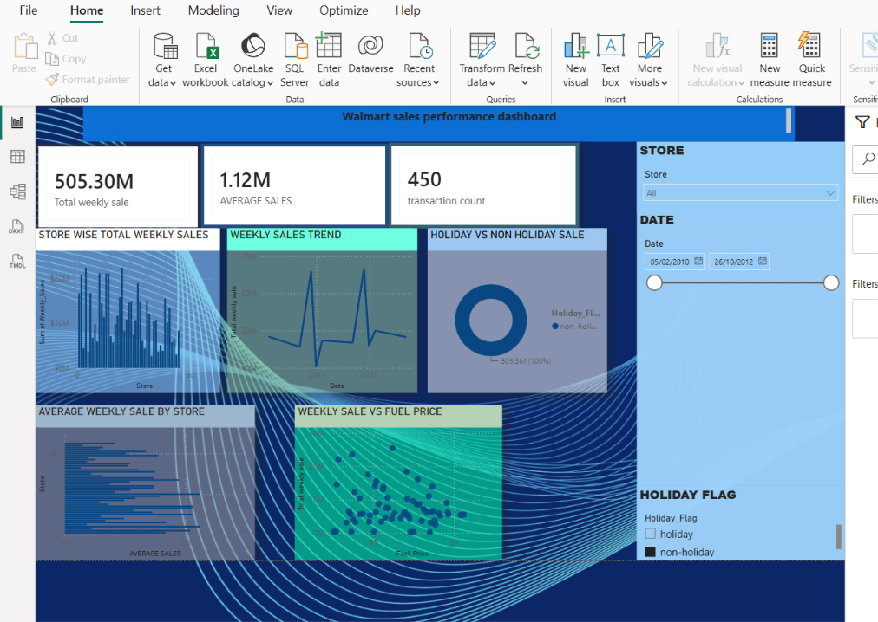

Overall Dashboard
This Power BI dashboard analyses weekly sales performance across 45 stores. The total weekly sales are approximately 6.73 billion, average sales are 1.05 million, and the dataset contains 6,436 transaction records.
The dashboard compares sales between stores and shows that some stores perform better than others. It also shows weekly sales trends, where some weeks have high sales due to holidays, offers, seasonal demand, or promotions.
Non-holiday weeks contribute 92.5% of total sales, while holiday weeks contribute 7.5%. This is mainly because non-holiday weeks occur more frequently. The fuel-price analysis shows no strong direct relationship between fuel price and weekly sales.
Overall, the dashboard helps management identify high-performing stores, improve low-performing stores, plan for high-sales periods, and make better business decisions.

Conclusion
The Power BI dashboard provides a clear overview of weekly sales across 45 stores. It helps compare store performance, identify sales trends, analyse holiday and non-holiday sales, and understand the effect of fuel prices. The analysis shows that some stores perform better than others and that sales change during different weeks. This dashboard supports management in improving low-performing stores, planning promotions, and increasing overall sales.

